Leir Center For Financial Bubble Research

Working Paper #13

International Product Cycles, East Asian Growth, And Effect MNE Strategies

William V. Rapp
H. J. Leir Professor International Business
New Jersey Institute Of Technology
rappw@njit.edu
973-596-6414 (phone)
914-923-1416 (fax)

Preface –

While not strictly a bubble paper, this paper notes a signal that China’s dramatic growth run may be ending, a development that might have implications among other consequences for what many see as a bubble in China’s hot property market. The apparent shift in comparative and competitive advantage from China to countries such as Bangladesh in labor intensive industries like apparel with open access to the latest technologies has historically signaled the beginning of a gradual slowing in economic growth after roughly 20 years of supercharged development. This occurred in England in the 19th Century, the US at the end of the 19th and beginning of the 20th Centuries, Japan in the 1950s and 60s, Korea in the late 70s and 1980s, Southeast Asia in the 1990s and now apparently for China. I will be presenting it at the SASE Meeting in Milan June 28, 2013.

ABSTRACT

The systematic migration or “Flying Geese” pattern of shifting competitive advantage in particular industries from one country to another first proposed by Kaname Akamatsu for the global textile and apparel industries and then extended by Ray Vernon and others to additional industries including steel, ships and automobiles gained much attention in the 1960s through the 1990s as Japan, Taiwan, Korea, the ASEAN Nations, and finally China sequentially entered and exited industries such as textiles, apparel, toys, electronics, steel, ships and cars. However as China has emerged over the last decade and a half as the world’s factory the International Product Cycle or Flying Geese theory seemingly lost its relevance as analysts appeared to assume China’s export competitiveness in low wage industries would continue indefinitely. But perhaps nothing continues indefinitely.

That is more recently China is experiencing the same economic forces in terms of increasing per capita incomes, labor skills, wages, land prices and price inflation as its predecessors such that textiles, apparel and similar low skill low pay industries after first shifting to lower wage areas within China itself are now migrating to lower wage countries such as Bangladesh, Cambodia or Indonesia. Thus China now too seems to be following the same “Flying Geese” pattern.

Introduction

The traditional Flying Geese or International Product Cycle theory shown graphically in Exhibit 2 finds its explanatory power in skill changes in the labor force, rising wages and the increased domestic and export demand for more sophisticated products as a country successfully develops and per capita incomes rise. But an important shift began in the 1980s through the influence of MNEs’ FDI on the evolutionary process because some of these firms could through FDI capture the demand that otherwise would have supported the development of new competitors or national champions in the follower countries. Companies such as Intel and Honda have been particularly adept at this process.

Further with advances in globalization since the 1980s that reduced barriers to trade and investment and combined with dramatic advances in communications and transportation many firms found they could create and optimize a global supply chain that allowed them to shift suppliers quickly as economic situations changed. This situation was true for manufacturers such as IBM and Toyota, branded consumer goods such as Apple, Nike and Disney and big box stores such as Walmart and Home Depot. It also occurred in less visible areas such as toys, nails and eyelashes.

These developments have had two major effects on trade and the FG pattern of development. One the MNEs can influence the competitive migration of particular industries from one country to another such as Nike’s decision to build a shoe factory in Vietnam rather than expand output in China, Walmart’s decision to shift low cost apparel production to Bangladesh or Sumitomo’s decision to go to Cambodia for wire harnesses used in cars [Bradsher, K. 2013].

Secondly these developments have impacted the ability for a national champion to emerge in a follower country to compete in global markets as major MNEs have remained globally competitive through FDI in these follower markets such as Toyota, Honda or Hyundai in automobiles. This continued global competitiveness in turn will redirect resources in follower nations to those companies and industries facing weaker competition.

This paper will look at the situation in East Asia in terms of the historical competitive migration of certain industries and why in particular those such as textiles, apparel and toys seem to move relatively easily along the lines of the international product cycle. At the same time it will examine those where the expected shift in competitive dynamics have been influenced through FDI from the strong global competitors of the innovator nation or earlier followers such as Japan that have successfully maintained their global competitive advantage and have thus prevented the emergence of a large number of new global players.

With respect to the latter phenomenon issues of innovation, organizational barriers, and factor reversal will be addressed along with an emerging need for quicker response times and the increase in situations where product demands and efficient customization are driving process rather than traditional mass production processes driving the product design.

Traditional Flying Geese Paradigm Of Industry Migration

For Akamatsu [1962] the process of competitive migration began with the UK in the 19th Century as the textile industry innovator and for Ray Vernon [1966] it began with the US as the innovator in a wide range of industries including autos, steel and electronics.

The idea is that with successful industrialization per capita incomes rise but there are shifts in demand to higher quality goods in existing industries such as textiles, apparel and electronics [Exhibit 1] and to demand for new more sophisticated products such as a movement from bicycles, to motorcycles to cars. Thus per capita income can be used as a measure of a country’s level of development and the kinds of products or services its population will demand over time [Rapp 1967].

These shifts in demand also represent a shift in comparative and competitive advantage as growth slows in the industries and products losing relative demand. At the same time there are always follower nations moving into that space that are gaining advantage through higher relative growth and lower labor costs. In this way as countries move up the value added ladder into higher quality technically more sophisticated products or services they shed industries in which they are losing relative advantage while gaining advantage in those immediately ahead relative to the countries that are more advanced in the development process.

Several countries in East Asia such as Taiwan, Korea, Singapore, Thailand and most recently China have explicitly followed this development model emulating in particular Japan’s industrial development and industrial policies from the 1950s through the 1970s [Rapp 1977]. In this way the theory tries to explain a country’s pattern of industrial development at a point in time as well as how it will evolve from that point.

Under the classic international product cycle theory a country is either an innovator or follower in a particular industry. If it is an innovator it is usually at the forefront of economic development and is first producing for its own local market and then for other more advanced countries in terms of exports [Exhibit 2]. The advanced followers are thus initially importers but as local demand grows they begin the production process again but because they are growing more quickly than the innovator they are gaining competitive and comparative advantage. So they begin exporting to the next follower, etc. [Exhibit 2].

Experience Curve Effects And Technology Transfer

While Akamatsu [1962], Vernon [1966] and Rapp [1967] were able to show that these product cycles and shifts in competitive and comparative advantage had actually occurred [Exhibit 3 autos] a theoretical problem did arise with respect to the FG theory with the identification of Experience Effects. That is beginning in the 1970s it could be verified that real costs dropped by a certain percentage for every increase in experience [accumulated production]. Thus logically the firm with the largest global market share would have a decisive competitive advantage that followers should never be able to match, an obvious paradox since such firms did lose competitive advantage.

The theoretical and actual solution to this paradox was resolved by showing the starting point for a follower’s new accumulated production curve was constantly falling over time due to technological improvements, knowledge spreading and education. It was also impacted by the exchange rate and lower labor costs. Thus follower countries in the early stages of development with weaker exchange rates, lower labor costs and access to global technologies could begin the production process at much lower initial costs than had been borne by the innovator [Exhibit 4 – autos] and only needed to grow faster in order to catch up and pass the innovator in terms of price competitiveness [Rapp 1973] as Japan did during the 1960s and 70s in autos [Exhibits 4 & 5].

This process was then followed by Taiwan in textiles and electronics and Korea in textiles, shipbuilding, steel, autos and electronics. Further in all three cases the countries were able to establish national champions that were then able to become major international global competitors such as Toyota, Nippon Steel, Sony, Matsushita, Honda, Mitsubishi Heavy, ITC, Acer, Hyundai, Posco and Samsung.

However in the 1980s things began to change. American firms such as Intel began to understand this process of competitive migration. In addition major Japanese firms that had so successfully initiated these developments against US and European competitors also had a clear understanding and were not anxious to be replaced competitively by the next follower as for instance Toyota had done with GM [Rapp 1993]. Organizational learning had thus occurred and new strategies were developed using Foreign Direct Investment [FDI] globally as a strategic tool.

The concept is to strategically use FDI to capture the growth in the follower country shutting off the possibility of a national champion and potential global competitor from developing and allowing the foreign firm to reap the benefits of the new lower experience curve and the rapidly growing local demand. At the appropriate time they could also establish a new and more competitive export platform. Honda for example has an explicit country strategy that relates per capita income to certain products such as 50cc motorbikes at an early development stage. Then as economic development progresses Honda moves their marketing emphasis up within the two-wheel category to bigger more expensive bikes and then it shifts to small four wheel vehicles and then moves up the automobile scale as the populace becomes more affluent.

This strategy also allows the company to begin training mechanics and to develop a service and distribution organization at a very early stage of a country’s motorization. At the same time it will shift production of those vehicles to that country as scale builds in each product category. Thus their global production for small motorbikes is no longer Japan but China and to the extent there is still Japanese demand for these bikes Honda imports them.

From this and other examples it is clear that the dynamics of the international product cycle and shifts in competitive and comparative advantage are still occurring and thus the theory remains valid and important. But globalization in terms of reductions in barriers to trade and investment combined with the major advances in communications and transportation that have enabled firms to manage complex global supply chains on a just in time basis have changed how each product cycle develops and is manifested. The current growth in intra-company trade relative to inter-company trade much less global production illustrates the business and policy importance of this fact [Hill 2010].

Yet it is clear that while for many industries such as autos and electronics FDI has changed the nature of the product cycle away from the creation of powerful new global competitors who are national champions this does not appear to be true for textiles and apparel or even for steel. Thus capital and scale do not appear to be the controlling factors. Rather it seems to be who controls the technology or intellectual property rights needed to be globally competitive.

If a country can easily access the latest technology and intellectual property rights are not an issue then lower labor costs can be a competitive advantage in industries such as apparel that are labor intensive. Since industrial sewing machine companies are happy to sell to anyone this condition applies to apparel especially when large retailers such as Walmart appeal willing to shift production to a new location for a few cents per hoodie [Hill 2010]. Further if emerging countries recognize this and are willing to support such Infant Industries under recognized international exceptions the industry can flourish as has occurred in apparel in Bangladesh [Hill 2010]. Indeed as Akamatsu [1962] noted textiles and apparel for this very reason tend to be bell weathers of shifting competitive dynamics.

This kind of industrial policy can even work in industries requiring much more capital such as steel or metal refining since again large engineering companies such as Bechtel, Brown-Boveri and the engineering division of Nippon Steel are ready to design and build such operations while equipment is readily available from firms such as Mitsubishi Heavy or Siemens. Therefore in these areas new National Champions such as Bao and Mittal Steel can and do emerge. Further as these companies grow rapidly in response to a country’s modernization they move down their experience curves more rapidly as well [Exhibit 4] and thus their country’s exchange rates for them become relatively undervalued promoting their exports and further cost reductions in a virtuous or beneficial cycle that will also tend to shift national resources to those sectors.

This is especially true when the access to global markets becomes easier. This is clearly demonstrated by how the ending of the MFA or Multi Fibre Arrangement [1974-2004] benefitted first China and then Bangladesh [Hill 2010]. Further the growth of these industries has also benefitted due to lower ocean transport costs from easier and less expensive access to raw materials such as cotton and synthetic fiber in the case of apparel, iron ore and coking coal in the case of steel and copper concentrates for copper smelting and parts or wire production. Further containerization has made low cost global distribution possible for the final product.

Balance Of Payments And Macroeconomic Effects

To start the process an emerging country and its firms will require capital. It will thus generally begin the process by borrowing capital that it in relative short supply and it will become an Immature Debtor. The more successful it is at this process the more its industries will grow and expand. It will therefore require more capital and will evolve into a Mature Debtor. Once it becomes globally competitive, however, it will begin exporting and start the shift to Immature Creditor status and finally Mature Creditor.

Japan, Taiwan, Singapore, Korea and now China are already at this final stage [Ozawa 2010]. This has led to accusations that they are maintaining at least in the case of China undervalued currencies. But this is less credible for a country like Japan that has seen its currency go from 360=$1 to under 100=$1. More complex economic factors therefore seem to be at work in ways that go beyond the scope of this paper [Aliber 2013 and McKinnon 2013]. Yet it does seem to be true that a successful exploitation of the international product cycle that results in an export-led-growth model does result in the build up of foreign exchange reserves in a neo-mercantilist manner.

FDI In The International Product Cycle

Though the use of FDI may not significantly change the development of an export led growth model from a nation’s development perspective it does seem to change the global competitive dynamics from a company perspective. That is when there has been MNE Organizational Learning and that MNE can control its technological, competitive and/or organization advantages on a global basis through tacit learning [Rapp 2004], its core competencies [Hill 2010], and/or intellectual property rights such as trademark [TM], copyright [©], or patents the competitive evolution of the international product cycle is quite different in that the emergence of national champions in mature industries becomes less likely and nations have less control from an industrial policy viewpoint on when production in a particular area will shift to the next follower.

Rather large retailers such as Walmart, Home Depot, Sears, Best Buy, Tesco, Marks & Spencer, H & M, 7-11, and Amazon, internationally recognized brands such as Apple, Hermes, Gucci, Brooks Brothers, and Sony and strategic investors such as Intel, Toyota and GE have become the drivers. Importantly their decisions in many cases are currently and will be in the future influenced by factors and considerations other than the industrial policies of their suppliers’ countries. Thus GE recently moved its part of its air conditioner production from Asia to the US because Walmart, Home Depot and Buy Best noted that their demand for room air conditioners rose and fell very quickly based on the first really hot day.

Thus they did not want to wait for GE to ramp up production in Asia and supply the increased demand after a long voyage by container vessel. Similarly for certain high value products such gas turbines, tour buses, servers, mainframe computers, aircraft, and mining equipment quality becomes more important than low cost and buyers are willing to pay more for high quality if its ensures their operations will operate continuously except for regular maintenance. In these cases the manufacturing paradigm of process [mass production] driving product design is reversed to where demand and design will drive process. Such considerations can also push firms towards more efficient customization [Rapp 2004] where the required skill set is very different than in the emerging markets thus impacting a major driver of shifting comparative advantage.

New Environment And Ability Manage Global Supply Chains

In this way the Large Retailers, the firms with well-recognized Global Brands, and the Strategic Investors, some of whom also possess global brands, do and will make the decision when shifts will take place in their global supply chains thus impacting Asia.

Loss Sovereignty

In sum the exploitation of shifts in comparative and competitive advantage has now shifted away from national industrial policies to the supply chain management strategies of large MNEs. This has implications for Asian economic growth in particular since Asian countries have been the most reliant on the export led growth strategies based on lower labor costs combined with a relatively skilled, disciplined and literate labor force. While the implications for economic growth in the region are currently unclear it would seem that if such decisions accelerate and become wider spread that Chinese exports and growth will decelerate while smaller countries on its periphery will grow more rapidly and will gain advantage in more labor intensive less technologically intensive products. Further this process may be accelerated by the FDI of Chinese firms seeking to maintain their existing supplier relationships with the big retailers and branded consumer goods.
Exhibits

Exhibit 1
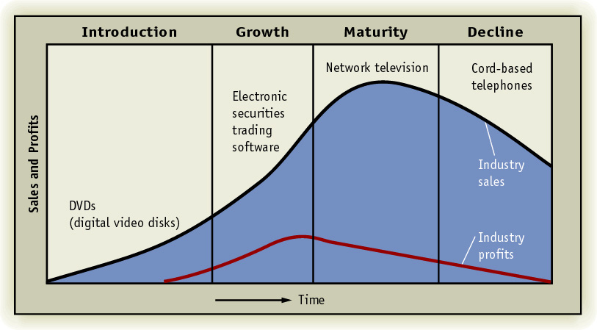
Exhibit 2

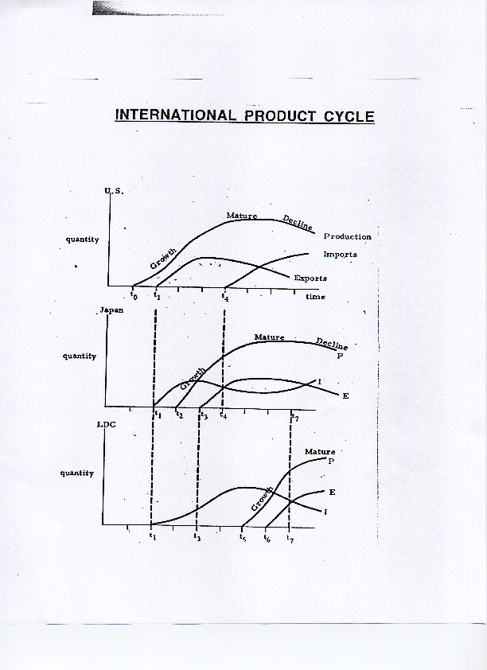
Exhibit 3 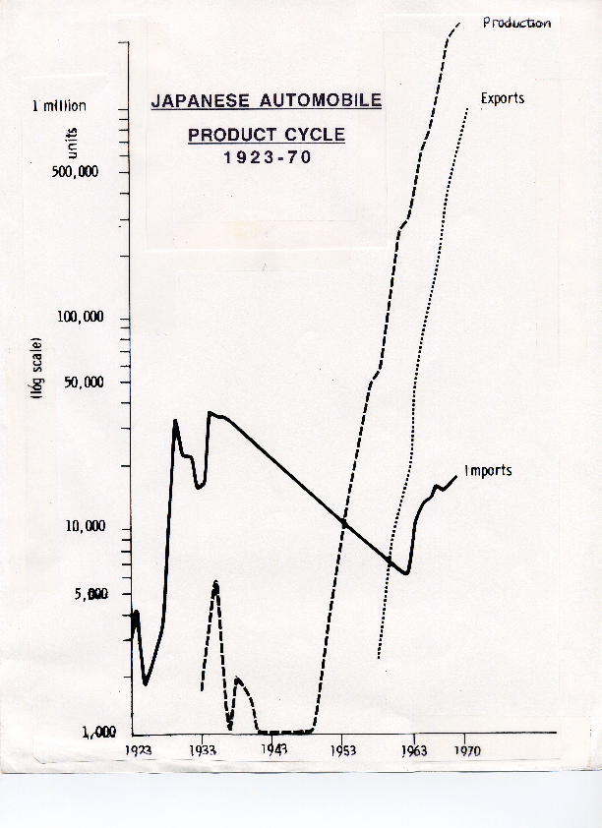
Exhibit 4
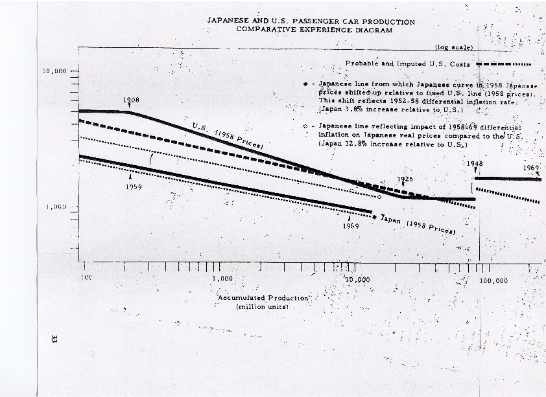

Exhibit 5
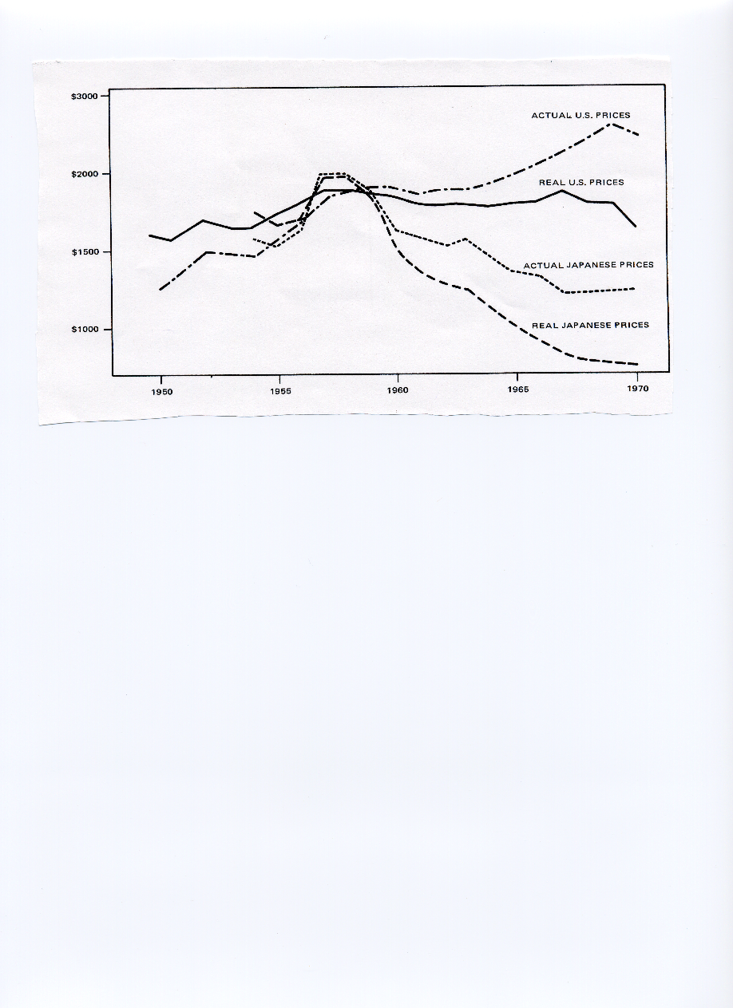
References

Akamatsu, K. 1962. “An Historical Pattern Of Economic Growth In Developing Countries,” The Developing Economies, 1, Tokyo, pp 4-25.

Aliber, R. 2013. “The Andy Warhol View Of The Economic Prospects For China,” Working Paper, Hanover, NH.

Barboza, D. 2006. “Shortage of cheap labor in China,” NY Times.

Bradsher, K. 2013. “Wary of China, Companies Head to Cambodia,” NY Times.

Hill, C. 2010. Global Business Today, 7th ed., McGraw-Hill, NY.

Kahn, J. 2003. “Chinese Girls' Toil Brings Pain, Not Riches,” NY Times.

Kindleberger, C. & Aliber, R. 2011. Manias, Panics And Crashes, Palgrave Macmillan, London, UK.

McKinnon, R. 2013. The Unloved Dollar Standard, Oxford University Press, Oxford.

Ozawa, T. 2010. “The (Japan-Born) ‘Flying-Geese’ Theory of Economic Development Revisited - and Reformulated from a Structuralist Perspective,” Working Paper Series, Center on Japanese Economy and Business, Columbia Univrsity, NY.

Rapp, W. 1967. "A Theory of Changing Trade Patterns Under Economic Growth: Tested for Japan," Yale Economic Essays, New Haven, Conn., pp 69-135.

Rapp, W. 1973. "Strategy Formulation and International Competition," Columbia Journal of World Business, Vol. VIII, No. 2, NY, pp 98-112.

Rapp, W. 1977. "Japan: Its Industrial Policy and Corporate Behavior," Columbia Journal of World Business, Spring, NY, pp 38-58.

Rapp, W. 1992. "Japanese Multinationals: An Evolutionary Theory," Europe. Japan. and America in the 1990s: Cooperation and Competition, Vol. III in Europe. Asia-Pacific Studies in Economy, ed. Leuenberger, T. & Einstein, M., Springier, Berlin, pp 221-267.

Rapp, W. 1993. "Japanese Foreign Direct Investment in the Product Cycle," Proceedings of the Association of Japanese Business Studies, January.

Rapp. W. 2004. Information Technology Strategies, Oxford University Press, NY.

Vernon, R. 1966. “International Trade and International Investment in the Product Cycle,” Quarterly Journal of Economics, 80 (2), pp 190-207.

Wikipedia 2013

Womack, J., Jones, D., & Roos, D. 2007. The Machine That Changed The World, Free Press, NY.

Kahn, J. 2003. “Chinese Girls' Toil Brings Pain, Not Riches,” NY Times, and Barboza, D. 2006. “Shortage of cheap labor in China,” NY Times.
Hill, C. 2010, Global Business Today. Other countries benefitting from the search for China alternatives are Thailand, Myanmar and the Philippines, Bradsher, K. 2013. “Wary of China, Companies Head to Cambodia,” NY Times.
Toyota has located assembly plants worldwide all using its lean production system [Rapp 2004]. Locations include a mix of emerging markets like Thailand but also advanced countries such as France and the US. This plant dispersion hedges operationally against changes in exchange rates and new competitors.
“The Multi Fibre Arrangement (MFA) governed the world trade in textiles and garments from 1974 through 2004, imposing quotas on the amount developing countries could export to developed countries. It expired on 1 January 2005. The MFA was introduced in 1974 as a short-term measure intended to allow developed countries to adjust to imports from the developing world. Developing countries have a natural advantage in textile production because it is labor intensive and they have low labor costs. According to a World Bank/ International Monetary Fund (IMF) study, the system has cost the developing world 27 million jobs and $40 billion a year in lost exports. However, the Arrangement was not negative for all developing countries. For example the European Union (EU) imposed no restrictions or duties on imports from the very poorest countries, such as Bangladesh, leading to a massive expansion of the industry there. At the General Agreement on Tariffs and Trade (GATT) Uruguay Round, it was decided to bring the textile trade under the jurisdiction of the World Trade Organization. The Agreement on Textiles and Clothing provided for the gradual dismantling of the quotas that existed under the MFA. This process was completed on 1 January 2005. However, large tariffs remain in place on many textile products. Bangladesh was expected to suffer the most from the ending of the MFA, as it was expected to face more competition, particularly from China. However, this was not the case. It turns out that even in the face of other economic giants, Bangladesh’s labor is ‘cheaper than anywhere else in the world.’ While some smaller factories were documented making pay cuts and layoffs, most downsizing was essentially speculative – the orders for goods kept coming even after the MFA expired. In fact, Bangladesh's exports increased in value by about $500 million in 2006.” [Wikipedia 2013].
The author saw these consideration at work in a Mercedes Bus plant in Turkey were customers paid tens of thousands of dollars more per bus to reduce corrosion and in a GE gas turbine plant in Hungary where customers paid more for turbines made with special alloys that would assure “only scheduled” maintenance.
Though not yet entirely clear, three other drivers that could shift competitive advantage and may influence and even reverse current supply chain decisions are working conditions in places like China and Bangladesh adversely affecting firm or brand image [Kahn 2003], available water, and lower energy costs in the US.

